**Module 6: Milestone 2**

Brady Chin

Colorado State University Global

CSC500-1: Principles of Programming

Dr. Steven Evans

June 23rd, 2024

**Module 6: Milestone 2**

In the second milestone project, we build on the first milestone project by adding a shopping cart class. This class consists of several methods to add, remove, modify, and print the items in our shopping cart. We also include a menu that prompts the user to choose what action they would like to run.

**Takeaway**

I found this milestone project much more difficult that the other milestone project and critical thinking assignments that we have completed so far. After completing it and looking at it from a birds-eye-view, we are just manipulating a list of items (Colorado State University Global, 2024). In my opinion, what made this so difficult was the scale of this project and passing information through classes. Although my code functions properly, I think that there are much more efficient ways to write this program.

With that being said, I think that this was by far the most helpful project in this course so far. As portfolio projects should be, it took everything that we have learned and put it into one, larger project. I found it very helpful that there was a large focus on passing data between methods and classes. This is something that has always confused me.

Moving forward, I am planning on using this milestone project as “documentation”. Something that I can refer to when developing other projects. I also plan on modifying and improving on this for the final portfolio project.

As always, I was thinking of ways that we can improve on the project as this stage. Since we created a ShoppingCart class, we could ask at the beginning of the program who is shopping. We could have multiple shoppers with different shopping carts and switch between each shopper to display different information.

**Coding Specifics**

While developing this project, it took me a while to understand `cart_items`. After adding an item to the `cart_items` list, I was having trouble printing a readable output since the list consisted of `ItemToPurchase` objects. This made the early stages quite difficult because it was hard to see what was being added to the list and how I can manipulate it.

The last step that I completed for this project was the `modify_item()` method. I found this difficult because we had to modify a class rather than a string. Furthermore, checking if the parameters have default values took me a while to figure out and took lots of trial and error. I referred to python documentation (python.org, 2024) to get some more information on how to best tackle this problem.

**GitHub Repository**

GitHub Repository: [LINK](https://github.com/bradychin/csu-global-projects/tree/25064b348c71ea10f3813f62773b051292e8f842/Principles%20of%20Programming/Milestones/Milestone%202)

Milestone 2 Project: [LINK](https://github.com/bradychin/csu-global-projects/blob/25064b348c71ea10f3813f62773b051292e8f842/Principles%20of%20Programming/Milestones/Milestone%202/Milestone2.py)

**Screenshots**

add_item():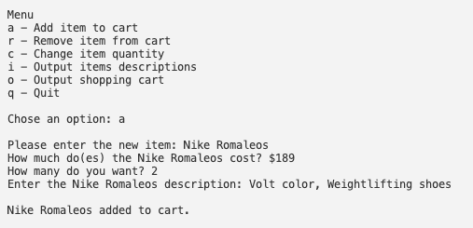

remove_item():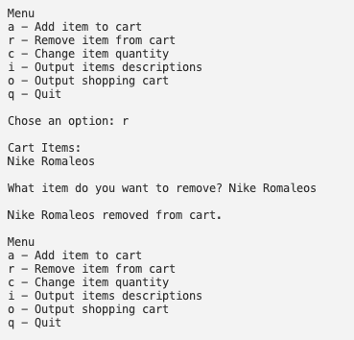

Quit: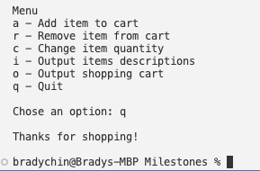

modify_ite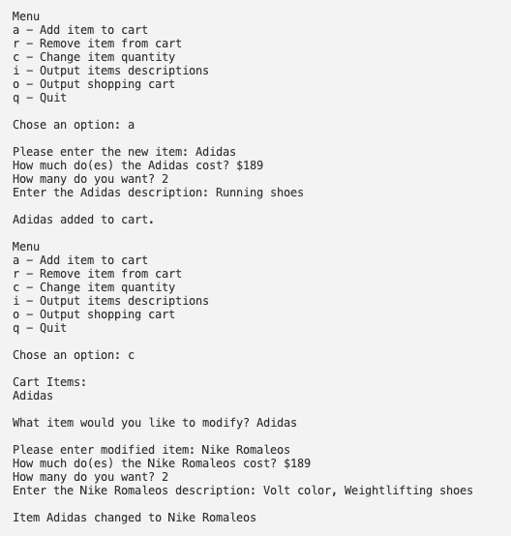m():

Item descriptions: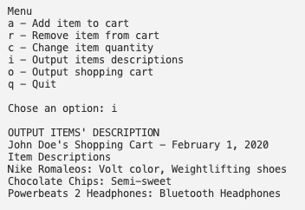

Shopping cart: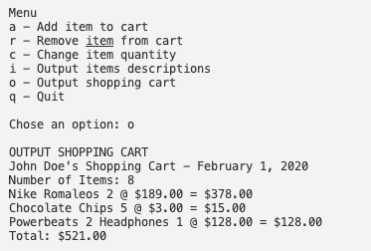

**References**

Colorado State University Global (2024, May 13th) *6.2 Manipulating Lists.*

<https://csuglobal.instructure.com/courses/93533/pages/6-dot-2-manipulating-lists?module_item_id=4786688>

Python Software Foundation (2024, June 21st) *inspect - Inspect live objects*

<https://docs.python.org/3/library/inspect.html>